Components of a routing table
- Prefix b)Network mask c)Next hop d)Routing protocol code e) Administrative distance f)Metric g)Gateway of last resort
Prefix- it refers to the network address that a router can see.
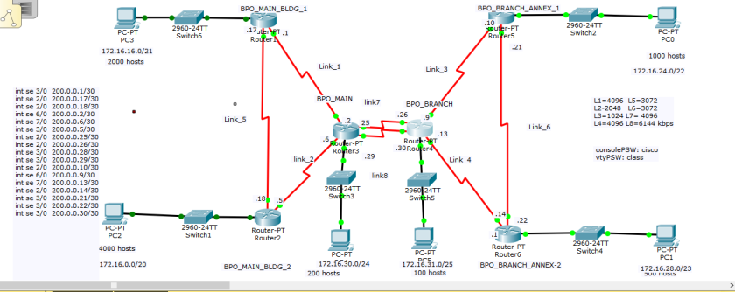
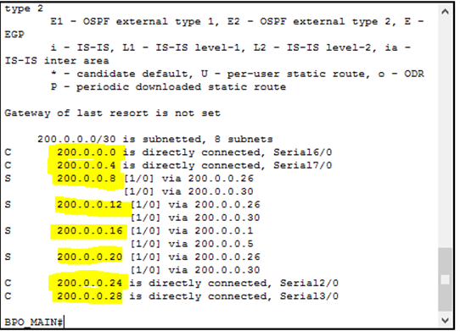
All the highlighted IP addresses are prefix.

Network Mask- Nothing complicated with the term” network mask”. Subnet mask is actually an abbreviation to subnetwork mask which means the mask of a portion of network subnettted.
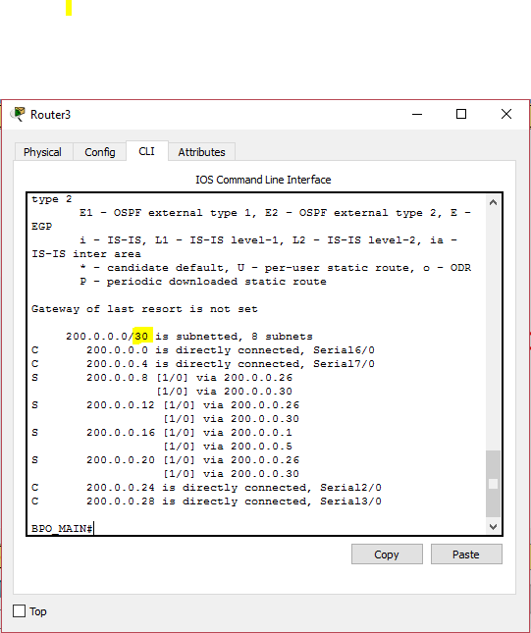
As you can see above, the network mask is highlighted which is 30 and it was subnetted to 8 subnetworks.

Next hop- The term next hop may refer to next hop router, next hop IP address or next hop interface.
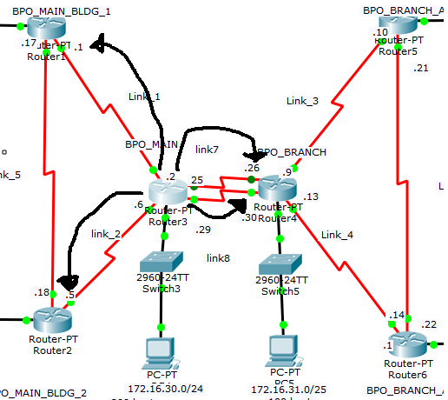
The picture above is the best to illustrate next hop. Router 3 or BPO MAIN ‘s next hop routers are MAIN BLDG 2,MAIN BLDG 1, and BPO BRANCH
In BPO MAIN’s perspective, the next hop IP addresses are 200.0.0.5, 200.0.0.1, 200.0.0.26 and 200.0.0.30

Routing protocol code
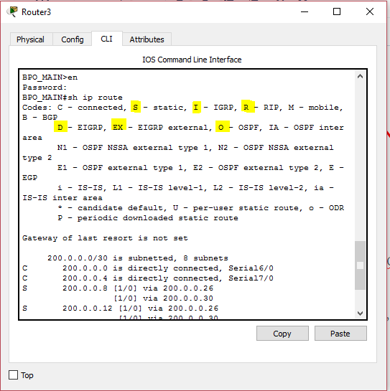
The highlighted protocol codes above represent the most commonly used routing protocols. As you can see as well below, network prefix 200.0.0.8 is learned using static protocol by forwarding the packet to directly connected IP addresses 200.0.0.26 and 200.0.0.30.

Administrative distance
There are almost two decision references for a router to determine what is the best path namely the administrative distance and the metric.
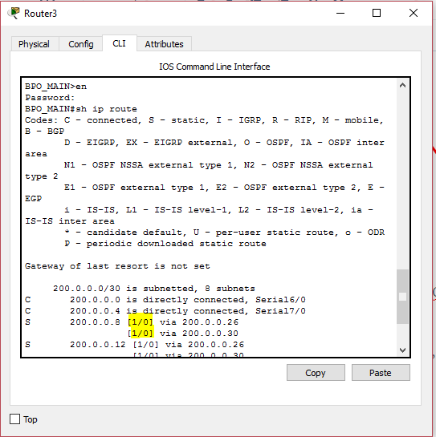
As you can see on the above image, on the prefix 200.0.0.8 –> [1/0] is the administrative distance and metric for static routing protocol.
The lower the administrative distance, the more the routers will believe that this is the best path

Common Administrative Distance:

1.) Directly Connected Networks – 0
2.) Static – 1
3.) OSPF – 110
4.) RIP – 120
5.) EIGRP -90

Logically, router will follow static routing because we assigned it, we manually configured the routing but then again it is not advisable to large networks.
Metric
What if I only used one routing protocol? How does a router will check the best routing selection?
Metric will be the reference if there is only one routing protocol.
Same theory applies; the lowest metric will have the best path.
Different routing protocols implement different routing metric. The following will be the metric of routing protocols:
RIP – hop
OSPF – costs
EIGRP – bandwidth + delay+ reliability+ load +MTU
BGP- attributes: weight, local preference, origin, AS path and multi exit discriminator

Gateway of last resort
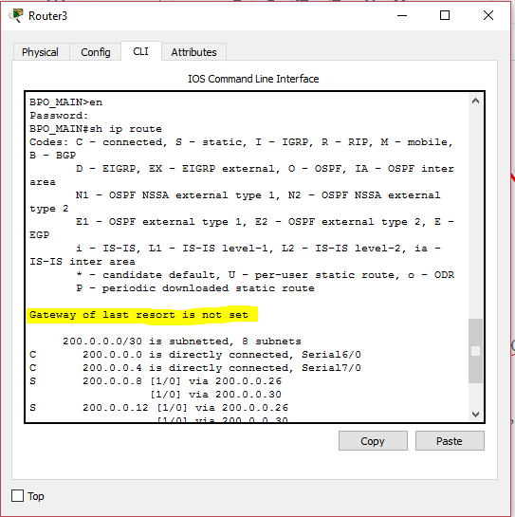
Gateway of last resort is the gateway we assigned on the router and serves as the path for LAN devices to be connected on the devices that pass through WAN links.

